The sensitivity to polarization in stratospheric aerosol retrievals from limb scattered sunlight measurements

B. J Elash, A. E. Bourassa, L. A. Rieger, S. R. Dueck, D. A. Degenstein

**Abstract: Satellite measurements of limb scattered sunlight at visible and near infrared wavelengths have been used successfully for several years to retrieve the vertical profile of stratospheric aerosol extinction coefficient. The existing satellite measurements are of the total radiance, with very little knowledge or impact of the polarization state of the limb radiance, by the intentional nature of the instrument design. Recently proposed new instrument concepts for stratospheric aerosol profiling have been designed to measure the linearly polarized radiance. Yet to date, the impact of the polarized measurement on the retrievals has not been systematically studied. Here we use a fully spherical, multiple scattering radiative transfer model to perform a sensitivity study on the effects of the polarized measurement on stratospheric aerosol extinction retrievals. In this study, we simulate both total and linearly polarized measurements, for a wide range of limb viewing geometries that are encountered in typical low earth orbit and for various aerosol loading scenarios. The orientation of the linear polarization with respect to the horizon is also studied. It is found that in general, the linear polarization can be used at least as effectively as the total radiance measurement, with consideration of instrument signal to noise capabilities. However, depending on the orbital geometry, one specific orientation of the linear polarization is favorable.**

# **1 Introduction**

Stratospheric aerosols, which are micron-sized spherical liquid droplets of sulfuric acid, cause a cooling effect by scattering the incoming solar irradiance and therefore have an important radiative effect on climate. This effect depends strongly on the aerosol concentration and also the particle size distribution (Kiehl and Briegleb, 1993; Stocker et al., 2013). Recent studies have proposed a link between the so-called global warming hiatus and an increase in the stratospheric sulfate aerosol layer. (Solomon et al., 2011; Haywood et al., 2014; Fyfe et al., 2013). The increase in stratospheric aerosol over the last decade is believed to be caused by a series of somewhat minor, mostly tropical volcanic eruptions (Vernier et al., 2011).

Stratospheric aerosol distributions have been monitored on a global scale since the 1970s with satellite instruments using a variety of remote sensing techniques. The first satellite aerosol extinction profile retrievals were from limb sounding solar occultation measurements, most notably from the NASA SAGE missions (Russell and McCormick, 1989; Thomason and Taha, 2003). The solar occultation technique has provided a robust and reliable method to retrieve aerosol by directly measuring the atmospheric optical depth. However, the global sampling of occultation measurements is somewhat limited due the necessity of a sunrise or sunset and typically requires months to cover a large range of latitudes. Limb scatter measurements, such as from OSIRIS (Llewellyn et al., 2004), SCIAMACHY (Bovensmann et al., 1999), and OMPS (Rault and Loughman, 2013), have better coverage by only requiring the sunlit conditions at the tangent point, but the retrieval of aerosol is more complex requiring computationally heavy forward modelling and inversion compared to occultation. It is worthwhile to note that the combination of the SAGE II and OSIRIS datasets have recently been used to successfully create a single long term merged time series depicting the evolution of the stratospheric aerosol layer (Rieger et al., 2015).

OSIRIS, SCIAMACHY, and OMPS measure the spectral radiance of the scattered sunlight from the limb and use non-linear inversion techniques to retrieve aerosol extinction profiles (Bourassa et al., 2012b; Ernst et al., 2012, Rault and Loughman, 2013). For these retrievals, assumptions regarding particle size distributions and/or composition are typically required in the forward model. Most importantly for this study, currently none of these retrievals account for any polarization sensitivity in their respective measurements. However, these instruments have been specifically designed to measure the total radiance by minimizing the instrument sensitivity to polarization. Recently proposed new instruments with the capability to measure aerosol using limb scattering include the Belgium instrument Atmospheric Limb Tracker for the Investigation of the Upcoming Stratosphere (ALTIUS) (Dekemper et al., 2012) and the Aerosol Limb Imager (ALI), a Canadian endeavour (Elash et al., 2016). Both instruments image the limb and use acousto-optic tunable filters to select the measured wavelength. The use of the acousto-optic filter inherently means that the measured image is linearly polarized. Although it has been previously shown that the retrieval of stratospheric aerosol extinction profiles from polarized scattered sunlight measurements are possible (Elash et al., 2016; McLinden et al., 1999), the full impact of the polarized measurement has not been systematically studied. In this work we perform an analysis with simulated polarized measurements to determine first if there are any clear advantages or disadvantages to making the linearly polarized measurement. Further, we investigate which linear polarization and viewing geometries have the largest sensitivities to aerosol, and how the polarized measurements affect the accuracy and precision of the retrieved aerosol product.

# **2 Background and Forward Model**

In order to investigate the effect of polarization on the sensitivity to aerosol, an accurate model of the polarized limb radiance must be employed. Additionally, a large number of scenarios, including various atmospheric states and viewing geometries, are required to fully probe the solution space. In this section, the basic background describing the polarization state of the limb signal is developed and the SASKTRAN-HR model and the various model scenarios used for the analysis are described.

## 2.1 Polarized scattered sunlight and stratospheric aerosols

The polarization state of electromagnetic waves can be fully defined by the Stokes vector formulation. The Stokes vector is given by a column matrix

$$I= \left[\begin{matrix}I \\ Q \\ U \\ V\end{matrix}\right] \left(1\right)$$

where the terms of the Stokes vector, defined in a reference frame, are measures of the total radiance, $I$, the difference between horizontal polarization to vertical polarization, $Q$, the difference between +45o diagonal polarization to -45o polarization, $U$, and the difference between the counter clockwise circular polarization to clockwise polarization, $V.$ Using a reference frame where the x-axis is defined to be the horizontal polarization leads to the following definition for the Stokes parameters

$$\begin{matrix}I= <E_{x}>^{2}+<E_{y}>^{2} \\ Q= <E_{x}>^{2}-<E_{y}>^{2} \\ U=2Re\left(<E_{x}><E_{y}^{*}>\right) \\ V= -2Im\left(<E_{x}><E_{y}^{*}>\right).\end{matrix}(2)$$

To model the scattering for an incident ray propagating in a given direction the ray undergoes a rotation into the Stokes reference frame and is then is multiplied by the phase matrix for the scattering process. After the multiplication the resulting ray is then rotated back into the ray’s initial coordinate system through the following

$$I^{sca}= L\left(θ_{2}\right)P(Θ)L\left(θ_{1}\right)I^{inc}. (3)$$

The outgoing, or scattered, and incoming radiances are represented 4 by 1 matrices, i.e. Stokes column vectors, given by $I^{sca}$ and $I^{inc}$, the rotation matrices are given by $L$ and rotate the incoming ray and scattered ray by rotation angles $θ_{1}$ and $θ_{2}$. The phase matrix is a 4 by 4 represented by $P(Θ)$ and is related to the probability that an incoming ray will be scattered at a scattering angle, $Θ$. It also describes the change in polarization state through the elements of the matrix.

For this work, two primary scattering interactions induce and/or modify the polarization state of the light propagating in the atmosphere. These are scattering by the molecular air density and by stratospheric sulfate aerosols. The molecular atmosphere interaction is referred to as Rayleigh scattering, and has a phase matrix that is determined from the Rayleigh-Gains approximation (Mishchenko et al., 2002) given by

$${P(Θ)}_{ray}=\frac{3}{4}\left[\begin{matrix}1+\cos^{2}{Θ} & -\sin^{2}{Θ} & 0 & 0 \\ -\sin^{2}{Θ} & 1+\cos^{2}{Θ} & 0 & 0 \\ 0 & 0 & 2cosΘ & 0 \\ 0 & 0 & 0 & 2cosΘ\end{matrix}\right] (4)$$

where $Θ$ is the scattering angle.

For randomly orientated or spherical particles, such as stratospheric aerosol, only six elements of the phase matrix are required (van de Hulst, 1957) which are the following

$$P(Θ)=\left[\begin{matrix}P_{11}(Θ) & P_{12}(Θ) & 0 & 0 \\ P_{12}(Θ) & P_{22}(Θ) & 0 & 0 \\ 0 & 0 & P_{33}(Θ) & P_{34}(Θ) \\ 0 & 0 & -P_{34}(Θ) & P_{44}(Θ)\end{matrix}\right] (5)$$

Additionally, for spherical particles like stratospheric aerosol only four unique terms are required since $P_{11}=P_{22}$ and $P_{33}=P_{44}$. Spherical aerosol scattering is fully described by Mie theory (Mie, 1908), for which several standard codes have been developed to calculate scattering cross sections and phase matrices based on the particle size distribution and index of refraction (e.g. Wiscombe, 1980). A full derivation can be found in van de Hulst (1957).

The basic polarization state of the scattered light in the earth’s atmosphere can be understood by first considering a single scattering event of the randomly polarized incoming sunlight in a molecular atmosphere. It can be easily seen from the form of the Rayleigh phase matrix (Eq. (4)) that a single scattering event causes the sky to develop a distinct polarization at a scattering angle of 90 degrees from the incoming solar beam. The scattered sunlight is linearly polarized in the horizontal orientation, which is parallel to the horizon, and gradually becomes fully randomly polarized at solar scattering angles (SSA) of 0 and 180 degrees. Backscatter is defined as when the SSA is greater than 90 degrees and forward scatter is when the SSA is less than 90 degrees. If multiple scattering events are taken into account, the degree of polarization is decreased at 90 degrees SSA, and does not become completely randomly polarized at 0 or 180 degree. Simulations with the SASKTRAN-HR forward model, which is described below, show that at 90 degrees SSA, the degree of linear polarization is approximately 95% for a wavelength of 750 nm. Furthermore, this polarized effect is strongest at longer wavelengths (1500 nm) and decreases, on average by 10%, as the wavelength become shorter (500 nm). This is directly related to the greater contribution from multiple scattering at shorter wavelengths. As the SSA or increases from 90 degrees, the degree of linear polarization decreases. It is approximately 20% for a back scatter geometry of 180 degrees, and 30% for a scattering angle of 45 degrees.

For an atmosphere that contains both the molecular air density as well as a typical background state of stratospheric sulfate aerosol, both Rayleigh and Mie scattering occur in a weighted fraction according to the optical depth of air and aerosol. Compared to the pure Rayleigh scattering case, a decrease in the degree of linear horizontal polarization occurs for wavelengths from approximately 500 to 1200 nm, and interestingly, for wavelengths longer than approximately 1200 nm, the opposite occurs which has a dependence on scattering angle. The absolute percent change in linear polarization can be seen in Figure 0.This is due to the changing fraction of scattering from the molecular air density and aerosol because the Rayleigh scattering cross section falls off much more quickly with wavelength than the aerosol cross section. These changes are similarly present for all scattering angles. The observed change in linear polarization from a pure Rayleigh atmosphere is approximately 5-10% for typical background aerosol, but it obviously varies depending on aerosol loading and the microphysical parameters of the aerosol.

## 2.2 SASKTRAN-HR model

The radiative transfer model SASKTRAN-HR (High-spatial Resolution) (Bourassa et al., 2007; Zawada et al., 2015) was used in this study. The SASTRAN-HR model provides flexible user specified atmospheric species and concentrations, and uses a fully 3D spherical geometry to solve the radiative transfer equation using a successive orders of scattering technique. SASKTRAN-HR also has the capability to calculate the polarized, or vector, radiances exactly for the first three scattering events, which contribute to most of the signal in limb scatter. The polarization states of higher orders of scattering are approximated with minimal impact on the final solution (Dueck et al., 2016). All calculations performed with SASKTRAN-HR in this study assume randomly polarized sunlight, and Rayleigh and Mie scattering events only to model the interaction with the molecular air density and stratospheric aerosol, respectively. Scattering events from the Earth’s surface are assumed to be Lambertian and fully depolarizing.

## 2.3 Model Scenarios

The impact of a polarized measurement on stratospheric aerosol retrievals is systematically studied by exploring a set of distinct cases that approximately cover the expected range of aerosol parameters, including both particle size and concentration (or extinction) profiles, and viewing geometries. Viewing geometry is an important parameter as even in the case of the total radiance measurements, the geometry can have a substantial effect on the sensitivity of the measurement to aerosol due to asymmetry of the Mie scattering phase function. (Rieger et al., 2014). This is due to strong aerosol scattering in the forward direction and results in a weaker relative aerosol signal in the back scatter direction. To probe a large portion of this parameter space, a series of scenarios were developed.

To probe the aerosol space, two extinction coefficient profiles and four particle size distributions were used. The two extinction profiles, nominally at 750 nm, correspond to a background aerosol case, typical of the volcanically quiet period of the early 2000’s (Deshler et al., 2003), and a volcanically enhanced case which was taken from OSIRIS measurements two months after the Nabro eruption in 2012. Both profiles are shown in Figure 1. For the simulations at other wavelengths, these extinction profiles were converted to an equivalent aerosol number density concentration using an assumed size distribution. This number density was then kept constant and the extinction scaled by the Mie scattering cross section corresponding to the selected wavelength and same assumed particle size distribution. The four particle size distributions were also chosen to represent typical background and volcanically enhanced cases. The background cases are both single mode lognormal distributions with somewhat different, but still typically observed, size parameters. A bi-modal lognormal particle size distribution was used for the volcanically enhanced cases, with one fine mode and one coarse mode, each comprising an equal fraction of the total extinction. All of the parameters of the size distributions are detailed in Table 1. These selected distributions are based on in-situ balloon particle counter measurements from Laramie, Wyoming (Deshler et al., 2003).

To probe the range of possible viewing geometries, a range of Solar Zenith Angles (SZAs) and Solar Scattering Angles (SSA) were selected. The ranges give representative selections of the possible geometries of a limb scatter instrument in low earth orbit. The selected values for SZA are 15 o, 45 o, and 75o and for SSA of 30o, 60o, 90o, 120o, 150o, and 180o. The simulations were performed at wavelengths of 500, 750, 1000, 1250, 1500 nm, which approximately cover for the spectral range commonly used for aerosol retrievals from limb instruments. For example, OSIRIS and SCHIAMACHY aerosol products use the ratio of 750 nm to 470 nm for the aerosol retrieval (Bourassa et al., 2012b; Ernst et al., 2012). Further near infrared wavelengths have been shown to provide particle size information from limb scatter measurements (Rieger et al., 2014) and so the 1000-1500 nm wavelength range was also important to include in this study. The other important input parameter is the albedo of the Earth’s surface and for this study we use both values of 0 and 1 in order to cover the full range of potential impact.

# 3 Methodology

For the purposes of this study, we have assumed an instrument capable of measuring only the linear polarization with either a vertical or horizontal orientation. This was chosen since upcoming instruments like ALTIUS (Dekemper et al. 2012) and ALI (Elash et al., 2016) use an acousto-optic tunable filter for a spectral filter and these instruments by nature only measure one orientation of linear polarization. We want to answer the question: if the linear polarization is measured, is this an advantage or a disadvantage over a measurement of the total radiance for aerosol retrievals? Further, is there a preferred orientation of linear polarization?

The polarization states used here are defined as the following: the linearly polarized radiance aligned with the horizon is referred to as the horizontal polarization, and the linearly polarized radiance that is perpendicular to the horizon is referred to as the vertical polarization. We also use the total radiance, or alternatively the scalar radiance, as the reference case. Note that the scalar radiance is not precisely equal to the total radiance. For the work presented here the total radiance will be defined as the $I$ stokes vector from the vector model, and the scalar radiance will refer to the radiance from the scalar model. Using the Stokes parameters, the total radiance is defined as $I$, the horizontal polarization is given by $0.5\left(I+Q\right)$ and the vertical polarization is given by $0.5(I-Q)$.

Our study looks at the problem in three sections. First, how does the fraction of the limb scatter signal, scalar and polarized, that is due to aerosol vary for a range of geometries and aerosol profiles? Secondly, how does the polarized measurement affect the ability to retrieve aerosol using an assumed particle size distribution, as is the case in the OSIRIS and SCIAMACHY retrieval algorithms? And finally, how does the polarized measurement effect the uncertainty estimate of the retrieved profile? Within this section the methodology for each question is described.

First in order probe the solution space simulated measurements were created using the scenarios describe in section 2.3, including various wavelengths, geometries and aerosol loading and particle size distributions. These simulated measurements are used to determine the approximate fraction of the limb signal that is due to aerosol. The range of geometries has been selected because the geometry that the measurement is recorded greatly effects the scattering cross section of aerosol. This change in cross section alters the quality of the measurement to aerosol sensitivity and the ability to accurately retrieve aerosol. Similar variations to the scatter cross sections occur has wavelength is also changed, for example the aerosol cross section becomes larger when compared to Rayleigh scattering at longer wavelengths. The model is run with a nominal atmosphere that consists of molecular air, ozone, and NO2 which is kept constant, and with a variable aerosol amount and albedo in order to be able to just determine the effect of aerosol on the measured radiance without the contamination from changing other atmospheric species. The aerosol fraction was determined by calculating the nominal radiance without aerosol in the model, $I_{nom}$, and the total radiance including the aerosol, $I_{tot}$, and using the difference between the total radiance and nominal radiance to find the approximate fraction of the signal due to aerosol. Thus to determine the percent of the signal that is attributed to aerosol, the following formulation is used

$$Percent_{aerosol}=\frac{I_{tot}-I_{nom}}{I_{tot}}*100\%. (6)$$

Due to non-linearities from multiple scattering, this is not strictly true; however at most stratospheric tangent altitudes, the wavelengths under study are quite optically thin and this simple percent difference will provide an intuitive approximation of the fraction of the signal due to aerosol. Furthermore, polarized measurements of radiance will be smaller in magnitude than the scalar counterpart and the percent loss will be used to estimate the increase in instrument sensitivity, or, for example, image exposure time, needed to compensate.

To determine the effect of polarization on the retrieval, a retrieval method is used that is essentially similar to that developed by Bourassa et al. (2012b) for OSIRIS. A minor change to the algorithm is made where the measurement vector for this study is not normalized by a shorter wavelength. We have made this change as the results from Rieger et al. (2014) show this actually decreases sensitivity to particle size distributions. Although it is advantageous to limit sensitivity to particle size, it is advantageous to explore the worst case scenario under possible limitations of future technology, especially given that not all instruments may cover a wide spectral range. For the retrievals, a simulated radiance profile is calculated using the SASKTRAN-HR model with nominal ozone and NO2 profiles for each of the aerosol parameter scenarios listed in section 2.3. This is taken as a simulated measurement and is then used to retrieve aerosol extinction profiles using the Bourassa et al., 2012b technique. This is done similarly for all three polarization states. Additionally, a retrieval is performed with the scalar SASKTRAN-HR model to see if there is any substantial difference between using the scalar radiance and the total radiance from the vector model. For each aerosol retrieval, the ozone, NO2, and albedo are fixed to the values used in the simulation of the measurement. All four particle size distributions from Table 1 are used in the simulations, but following Bourassa et al., 2012b, the aerosol particle size is fixed in the retrieval to a single mode log-normal with 0.08 µm mode radius and mode width of 1.6. The assumption of a fixed particle size distribution is very common in current limb scatter retrievals and this is used to explore sensitivity of the polarized measurements to particle size distributions, and test if the uncertainty in this assumption greatly effects the retrieved extinction.

Lastly, an uncertainty estimate is performed in order to check the precision of the retrieved aerosol profile. The precision is determined by mapping the covariance of the measurement vector, $S_{ϵ}$ through the gain matrix, which describes the sensitivity of the retrieval to the measurement and the respective noise through the following (Rodgers, 2000)



where $S_{aero}$ is the aerosol co-variance matrix. However, the direct calculation of the gain matrix is computationally intensive and requires a retrieval for each measured altitude. A method presented by Bourassa et al. (2012a) uses the Jacobian, $K$, to approximate the gain matrix by assuming the problem in linear, which is true since the optical depth is small for all selected scenarios and the computation of the Jacobian is more computationally efficient than the gain matrix. Using these assumptions the gain matrix can be determined through



For the method presented here the covariance is unknown since a generic instrument analysis is being performed. Instead the measurement co-variance matrix in equation (7) is replaced with the identity matrix. Through this replacement the result in the magnitude of the $S_{aero}$ representing the amplification of the noise (i.e. The larger the value of $S_{aero}$ the larger the uncertainty for the retrieval).



 Finally, the square root of the diagonal of the aerosol covariance is taken as the final amplification of the measurement noise. This method is performed twice since there are two primary methods which a polarized measurement might be occurring. First, an instrument that is being built with polarization in the design considerations so it is compensated therefore all polarizations measures the same incoming signal. This case uses the method described above. And second, where an existing instrument is being modified to measure a polarization without changing the instrument calibrations so each polarization will have different measured signal level. To perform this scenario the above method must be modified by altering the identity matrix to a relative scaled matrix, $R$, to represent the change in signal strength for the various polarizations compared to the scalar case. The relative scaled matrix is defined as



The diagonal of the $R$ matrix is effectively scaled by inverse of the signal strength of the current polarization, $I_{pol,i}$, compared to the to the base case,, for the measurement altitude, $i$. Using the results from both methods across all the cases, statistics are used to determine any trends in the obtained precision across the input parameters.

# 4 Analysis

## 4.1 Aerosol Sensitivity

First, the contribution to the total limb radiance from aerosol was analyzed across the spectral range and over a series of tangent altitudes for the background aerosol profile and the particle size distribution #1, given in Table 1. Figure 2 shows the difference between the fraction of the limb radiance due to aerosol for a linearly polarized measurement and the fraction due to aerosol for the total radiance measurement given a typical geometry of SZA=45o and SSA=60o with an albedo of 0. Note that the fraction of the signal due to aerosol increases as wavelengths become longer as expected due to the rapidly decreasing Rayleigh cross section. However, the fraction of the signal due to aerosol increases with wavelength for the vertical polarization as it does in the scalar case, whereas the horizontal polarization has decreasing sensitivity to aerosol.

A similar analysis was performed for the range of viewing geometries. The left half of Figure 3 shows the fraction of aerosol signal for 15 km tangent altitude, with the background aerosol profile and an albedo of 0 and size distribution #1. An important difference is noted between the forward and back scattering geometries. The scalar and horizontal polarization cases have a similar dependence on geometry, with the strongest aerosol signal from long wavelengths in the forward scatter direction. For the vertical polarization, we see that it has a strong aerosol signal contribution for all forward scattering directions, especially at visible wavelengths, in comparison to the scalar and horizontal polarization cases. For back scattering, slightly less aerosol signal is observed, but the shape is similar to the scalar and horizontal cases. The magnitude of the limb radiance in each case is shown in the right hand column of Figure 3. It is important to note that the vertical polarization has a very low magnitude at scattering angles near 90 degrees, as shown in Figure 3. This makes this geometry very difficult to use reliably. We performed these same calculations for the full range of SZAs and found that the SZA only effects the fraction of the signal due to aerosol by less than 1%. Lastly, when the albedo is changed from 0 to 1, the aerosol signal decreases for all polarizations, especially the vertical polarization, and wavelengths thus reducing overall sensitivity to aerosol as albedo increases. The ground reflection yields additional total radiance while keeping the contribution from aerosol approximately the same yielding less signal contributed from aerosol overall. Furthermore, the SASKTRAN-HR model assumes that all ground reflection will be randomly polarized; the addition of a BRDF model may change the sensitivity of aerosol with higher albedo, but the current SASKTRAN-HR model does not currently support the use of BRDF.

As we can see from these results, the sensitivity of the limb radiance to aerosol for the horizontally polarized and total scalar cases is approximately the same, and the vertical polarization has better sensitivity in the forward scattering case. However, only measuring the linear polarization results in a loss of overall signal. In Figure 4, the ratio of the polarized radiance over the total radiance is shown for a SZA of 45o and SSA of 60o, in this case using the volcanic aerosol extinction profile. Measuring the horizontal polarization would result in only observing approximately 58% of the signal for shorter wavelengths compared to the scalar case, and at longer wavelengths this increases but only to approximately 66% for a SSA of 60 degrees. For the back scatter case, for example 180 degrees, the observed signal decreases slightly to 52% at short wavelength and 56% at long wavelengths. Finally for SSA near 90o the observed signal increases to 83% at short wavelengths and 95% for long wavelengths compared to the scalar case. Across the parameter space tested about 70% of the incoming signal is retained compared to the scalar case and the ~30% signal loss would need to be accounted for by a corresponding increase in instrument sensitivity to maintain an equivalent signal to noise ratio in the measurement.

For the vertical polarization, however, the increased aerosol fractional signal in the forward scatter case is compensated with a larger loss of overall signal. For forward scatter (SSA of 60 degrees) only 38% and 34% of the signal are observed for 500 nm and 1500 nm respectively. Similarly for back scatter (SSA of 120 degrees) 48% and 44% of the signal is observed when compared to the scalar case. At SSA near 90o the signal decreases to 15% overall. This is a significant loss of signal and accounting for the whole probed space results in only measuring approximately 30-40% of the signal compared to the scalar case that would result in increasing the instrument sensitivity by approximately 60-70%.

Initially as the amount of aerosol in the atmosphere increases, so does the percent of the signal which is attributed to aerosol. However, eventually an increase in aerosol will result in little change or negative change to the aerosol measurement vectors typically used in aerosol retrievals. These measurement vectors are a similar quantity to the percentage fraction of aerosol signal, except the fraction is performed in log-space has the advantage of noted where a loss of sensitivity area where a loss of aerosol sensitivity is occurring due to the atmosphere no longer being optically thin which results In . The measurement vectors shown in Figure 5 are similar to the measurement vectors used by Bourassa et al. (2007) except the short wavelength normalization has been removed. In Figure 5, the background aerosol profile is successively scaled to higher values and the aerosol measurement vector is calculated for each scaled valued. These simulations are performed with a SZA of 60o and SSA of 45o and with an albedo of zero. In all cases the measurement vector increases as the aerosol load is increased until a maximum value is reached. For example, for the total scalar, horizontal, and vertical polarization this occurs at a scale factor of approximately 10, 11, and 8, respectively, at 25 km tangent altitude. As the aerosol loading is further increased from this point the measurement vector starts to decrease in value representing the maximum aerosol extinction for which that each polarization has sensitivity. Furthermore, a negative measurement vector is noted for lower altitudes. The loss of signal is due to the larger fraction of attenuation of the solar radiance over the increased aerosol scattering as the extinction coefficient approaches these large values (see Bourassa et al., 2007 for a more detailed explanation). This eventually leads to an aerosol loading limit beyond which retrievals are not possible. At shorter wavelengths, the best range of aerosol loading sensitivities is found for the horizontal polarization, followed by the total scalar case. However, for longer wavelengths (i.e. 1500 nm) the measurement vectors do not reach a peak value even at a scaling factor of 20 for all three polarization cases.

When considering the orientation of linear polarization for an instrument design there is no clear choice when it comes to sensitivity. Both the horizontal and vertical linear polarization are valid choices depending on the instrument and orbit of the mission in question. The vertical polarization provides the best sensitivity to aerosol in the forward and back scattering cases but should be avoided if any substantial fraction of the measurements are to be made near scattering angle of 90o for the proposed orbit. In terms of sensitivity, the horizontal polarization is preferable since overall signal levels are higher and generally a larger range of aerosol loading is detectable.

## 4.2 Retrievals

Retrievals were performed for all of the wavelengths listed in section 2.2, however due to similarities between the retrievals of different wavelengths only the 750 nm wavelength will be presented, with comments on the other wavelengths when significant deviations from the 750 nm case occur.

Retrievals with current limb scatter instruments use a scalar radiative transfer model and produce excellent results; however the use of a scalar model may lead to biases when modeling the radiance in the forward model compared to a vector model that could result in systematic biases in the final retrieval. Accounting for the vector component in the model alters the overall total radiance from the scalar solution due to multiple scattering of the vector radiance contributing to the overall radiance though the phase matrix interactions between the various polarization states. A brief study was performed to determine if using a scalar model for these retrievals instead of the total radiance from the vector model would result in biases in the retrieved aerosol profiles. A comparison between the retrieved extinctions for the scalar and vector model were performed using a percentage difference in the form

$$Percent Difference=\frac{k_{vector}-k_{scaler}}{k_{vector}}*100\%. (9)$$

Across all wavelengths, the mean percent difference is less than 2% from 15 to 37 km. However, at shorter wavelengths, shown in Figure 6, a few outliers occur where the difference between the retrievals is greater than 7%. All of these retrievals occur in the back scatter condition. The reason for this discrepancy is not well understood, but arises from the differences between the scalar and total radiance due to polarization interactions from a larger contribution of multiply scattered light, but further investigation is required. However, overall the differences between the retrievals using the scalar and vector models are negligible and any form of discrepancy vanishes for wavelengths past 1000 nm. Since the use of the vector model can increase calculation times by a factor of at least two, it is beneficial to be able to use the scalar model and can be used reliably for essentially all cases.

Aerosol profiles were retrieved using an assumed particle size distribution, in this case a log-normal with a mode radius and width of 0.08 µm and 1.6 respectively, which was different in all cases than the “true” state used to simulate the measurements. The comparison between the retrieval results at 750 nm for simulations of all three polarization states is shown in Figure 7. It should be noted that geometries with SSA of 90o have been removed for the vertical polarization due to the low values of overall signal, which creates a large dependency on the particle size distribution and a biased retrieval. However, geometries with a SSA of 85o or 95o almost eliminates the bias seen at the 90o scattering angle and it is completely eliminated once the scattering angle is less than 80o or greater than 100o.

Each of the four size distributions were used to simulate the measurements for the retrieval in order to test for any persistent biases in the various polarization cases. Recall that in all cases, the retrieval assumes a constant size single mode size distribution that does not match any of the four size distributions used to simulate the measurements. For particle size distribution 1 (see Table 1), retrieved aerosol extinction profiles are too large. For scalar, horizontal, and vertical polarizations had mean offsets of 9-13%, 12-17%, and 6-8% respectively from 17 to 35 km. Particle size distribution 2 shows a larger mean offset that also has a higher variance. The mean offset for distribution two are 20-28%, 24-31%, and 12-16% for the same polarizations from 17 to 35 km. For distributions three and four, similar variances are noted between the similar fine modes but the aerosol extinction retrieved is now much smaller than that true extinction state for all three polarizations. For distributions 3 and 4, the mean offsets were -42-44%, -40-43%, and -45-46% and -26-33%, -22-29%, and -38-42% respectively for the same polarization ordering. Furthermore, as wavelength increases an approximately 3-5% decrease in offset is observed for the retrieved aerosol profiles for each polarization. Current satellite instruments only agree to each other within 20-30% and using the above trends, accurate aerosol retrievals could be obtained for atmospheric states where only a fine mode exists. However, when a coarse mode is present in the true state, the retrieval significantly underestimates the amount of aerosol in the atmosphere.

Overall, both horizontal and vertical linear polarizations retrieve similarly accurate aerosol profiles when compared to the scalar case using an assumed particle size distribution. For fine mode cases the extinction retrievals are generally too large but only differ from the true state on average by 12-30% for the horizontal polarization and 12-17% for the vertical polarization. For a volcanic particle size distributions (case 3 and 4) the aerosol extinction retrieved is much too small, up to approximately 45% for both polarizations. However these result are similar to the scalar case.

## 4.3 Precision analysis

Using SASKTRAN-HR, the Jacobians for all the retrieved aerosol profiles were calculated and inverted to determine the gain matrices. These were used as shown in in Eq. 7 to determine the retrieval precision. It should be noted that not all of the Jacobians could be inverted due to negative sensitivity of the lower tangent altitudes (Bourassa et al., 2007) and these were removed from the data set (approximately 9% of total cases). Additionally This study will be performed for two primary cases, a sensitivity adjusted system, and an unadjusted system.

For the first case, it will be assumed that the instrument is compensated so the same signal levels are measured for each polarization. Remembering from section 3 that the measurement co-variance from Eq. 7 is replaced with the identity matrix and the relative size of the square root of the diagonal of the aerosol co-variance represents the amplification of the measurement noise. The horizontal and vertical polarization aerosol co-variance are normalized by the scalar case and are separately by each of the parameters in section 2.3 and averages for each altitude from 14 to 27 km are calculated. When observing the normalized co-variances for across the range of the tested parameters significant variance was noted for the SSA and wavelength parameters. When wavelength is observed, as seen in the top panel of Figure 8, the vertical polarization provides more precise aerosol profiles than the either case, on average 25% better than the scalar case at 750 nm with the worst case variance at 7% worse than the scalar case, and as the wavelength increases to 1500 nm the precision of the scalar and vertical polarization are approximately equal. The horizontal polarization is less precise than the scalar case for 750 nm, typically seeing 33% larger uncertainties, and at worst 92% degrade over the scalar case. Further, as the horizontal polarization reaches longer wavelengths the size of the uncertainty decreases until the scalar and horizontal polarization have approximately the same overall precision. For SSA the vertical polarization typically 7-10% better than the scalar case for all angles tested except 90 degrees which is due to the lack of sensitivity in this region noted previously. Furthermore, the variance of the uncertainty increases as the scattering angle approaches 90 degrees. For the horizontal polarization the uncertainty is 3-8% worse than the scalar case for backscatter and 8-16% worse for forward scatter, with a standard deviation of approximately 26.5% across all scattering angles. For the SZA, albedo, fine mode and coarse mode particle size, and fraction coarse mode has little effect on the overall precision for the polarizations as they are changed compared to the scalar case. The vertical polarization has uncertainty values are typically 16% smaller than the horizontal case and at the extreme the vertical polarization is 72% better than the horizontal.

Secondly, for an uncompensated instrument, (i.e. a linear polarizer has been added to the optical chain with no other changes) the relative scaled method is used as outlined in section 3. Due to the larger signal in the horizontal polarization compared to the vertical polarization the horizontal polarization generally has a smaller amplification of noise, except when the wavelength is 750 nm where the vertical polarization preforms better. This can be seen in the lower panel of figure 8, remembering that larger values corresponds to larger amplification of noise. It should be noted that since the linear polarization are always just a fraction of the total radiance the uncertainty is always larger than the scalar case (Note a normalized co-variance as seen in figure 8 has the same uncertainty as the scalar case when the value is 1). It should be noted that once again varying the SZA, albedo, fine mode, coarse mode, and fraction of coarse mode does not have a large effect on changing the size of the uncertainty where the vertical and horizontal polarizations have approximately a 58% and 32% larger uncertainty than the scalar case. Furthermore, the SSA only matters in this case as the vertical polarization approaches a SSA of 90 degrees due to the lack of sensitivity and the SSA has negligible effect on the uncertainty of the horizontal polarization.

To select a polarization for an instrument to yield high precision measurements of aerosol depends on whether the device has normalized the signal for the selected polarization or if the instrument is uncompensated from the scalar case with just the addition of a polarizer. If a compensated instrument is assumed the vertical polarization achieves higher precision. For an uncompensated instrument the horizontal polarization achieves higher precision unless all or most the measurement will be taken at wavelengths around 750 nm then the vertical polarization is superior. As a final note the vertical polarization should not be used if a majority of the measurements have a SSA of 90 degrees due to the poor sensitivity in this region.

# **5. Conclusions**

Overall choice for a polarized instrument that can only measure one polarization focused at retrieving high quality aerosol products is not a simple answer and depends on several parameters. The overall best situation would be an instrument that measures forward scattered light with vertical polarization with compensated instrument sensitivities. Recall that the vertical polarization is defined as the polarization normal to the horizon. In this orientation, the radiance measurement has good sensitivity to aerosol across all altitudes greater than 13 km. However, the increased sensitivity, especially at the shorter wavelengths, falls off quite rapidly as a SSA of 90o is reached and then increases again for SSA to 180o. This instrument would also yield the best precision possible but it has two disadvantages. First, assuming a particle size distribution scattering angles close to 90o contain a large bias in the retrieved aerosol extinction compared to the scalar case and true state. Second, a large loss of the overall signal occurs from measuring the vertical polarization, up to 70% which would require a large increase in instrument sensitivity compared to the scalar case. Depending on instrument specifications, the required increase in sensitivity may result in unacceptably instrument parameters.

If more signal is required or the orbit will result in a high percent of measurements around SSAs of 90o, the horizontal polarization should be used. However, the preference would be for forward scatter at the longer wavelengths since a loss of aerosol signal occurs at shorter wavelengths. This would result in the highest possible aerosol signal in the radiance. Furthermore, a maximum of loss of signal would only be 42% which is considerably better than the vertical polarized case.

As a final note, the agreement between the scalar and vector SASKTRAN-HR model are generally within 2% of each other for the aerosol retrievals. It is promising that the inclusion of polarization in the model does not cause a large change to the retrieved profiles since the use of the vector model would result in an approximate doubling in processing time.

# Acknowledgements

NSERC?

# References

Bourassa, A. E., D. A. Degenstein, R. L. Gattinger, and E. J. Llewellyn (2007), Stratospheric aerosol retrieval with optical spectrograph and infrared imaging system limb scatter measurements, Journal of Geophysical Research, 112, D10217, doi:10.1029/2006JD008079.

Bourassa, A. E., C. A. McLinden, A. F. Bathgate, B. J. Elash, and D. A. Degenstein (2012a), Precision estimate for Odin-OSIRIS limb scatter retrievals, Journal of Geophysical Research: Atmospheres, 117, D04303, doi:10.1029/2011JD016976.

Bourassa, A. E., L. A. Rieger, N. D. Lloyd, and D. A. Degenstein (2012b), Odin-OSIRIS stratospheric aerosol data product and SAGE III intercomparison, Atmospheric Chemistry & Physics, 12, 605-614, doi:10.5194/acp-12-605-2012.

Bovensmann, H., J. Burrows, M. Buchwitz, J. Frerick, S. Noël, V. Rozanov, K. Chance, and A. Goede (1999), SCIAMACHY: Mission objectives and measurement modes, Journal of the Atmospheric Sciences, 56, 127-150.

Dekemper, E., N. Loodts, B. V. Opstal, J. Maes, F. Vanhellemont, N. Mateshvili, G. Franssens, D. Pieroux, C. Bingen, C. Robert, L. D. Vos, L. Aballea, and D. Fussen (2012), Tunable acousto-optic spectral imager for atmospheric composition measurements in the visible spectral domain, Applied Optics, 51, 6259-6267, doi:10.1364/AO.51.006259.

Dueck, S., A. E., Bourassa, and D. A. Degenstein (2015), SASKTRAN-HR Polarization Module, In Preparations.

Deshler, T., M. Hervig, D. Hofmann, J. Rosen, and J. Liley (2003), Thirty years of in situ stratospheric aerosol size distribution measurements from Laramie, Wyoming (41 N), using balloon-borne instruments, Journal of Geophysical Research: Atmospheres (1984-2012), 108.

Elash, B. J., A. E. Bourassa, P. R. Loewen, N. D. Lloyd, and D. A. Degenstein (2015), The Aerosol Limb Imager: Acousto-Optic Imaging of Limb Scattered Sunlight for Stratospheric Aerosol Profiling, Atmospheric Measurements and Techniques, In Procedings

Ernst, F., C. von Savigny, A. Rozanov, V. Rozanov, K.-U. Eichmann, L. A. Brinkho, H. Bovensmann, and J. P. Burrows (2012), Global stratospheric aerosol extinction profile retrievals from SCIAMACHY limb-scatter observations, Atmos. Meas. Tech., 5, 5993-6035, doi:10.5194/amtd-5-5993-2012.

Fyfe, J. C., N. P. Gillett, and F. W. Zwiers (2013), Overestimated global warming over the past 20 years, Nature Climate Change, 3, 767-769.

Haywood, J. M., A. Jones, and G. S. Jones (2014), The impact of volcanic eruptions in the period 2000-2013 on global mean temperature trends evaluated in the HadGEM2-ES climate model, Atmospheric Science Letters, 15, 92-96, doi:10.1002/asl2.471.

Kiehl, J. T., and B. P. Briegleb (1993), The relative roles of sulfate aerosols and greenhouse gases in climate forcing, Science, 260, 311-314, doi:10.1126/science.260.5106.311.

Llewellyn, E., N. D. Lloyd, D. A. Degenstein, R. L. Gattinger, S. V. Petelina, A. E. Bourassa,J. T. Wiensz, E. V. Ivanov, I. C. McDade, B. H. Solheim, J. C. McConnell, C. S. Haley,C. von Savigny, C. E. Sioris, C. A. McLinden, E. Grifoen, J. Kaminski, W. F. J. Evans, E. Puckrin, K. Strong, V. Wehrle, R. H. Hum, D. J. W. Kendall, J. Matsushita, D. P. Murtagh, S. Brohede, J. Stegman, G. Witt, G. Barnes, W. F. Payne, L. Piche, K. Smith, G. Warshaw, D. L. Deslauniers, P. Marchand, E. H. Richardson, R. A. King, I. Wevers, W. McCreath, E. Kyrola, L. Oikarinen, G. W. Leppelmeier, H. Auvinen, G. Megie, A. Hauchecorne, F. Lefevre, J. de La Noe, P. Ricaud, U. Frisk, F. Sjoberg, F. von Scheele, and L. Nordh (2004), The OSIRIS instrument on the Odin spacecraft, Canadian Journal of Physics, 82, 411-422, doi:10.1139/p04-005.

McLinden, C. A., J. C. McConnell, C. T. McElroy, and E. Griffioen (1999), Observations of Stratospheric Aerosol Using CPFM Polarized Limb Radiances, Journal of the Atmospheric Sciences 1999 56:2, 233-240, doi:10.1175/1520-0469(1999)056<0233:OOSAUC>2.0.CO;2.

Mie, G. (1908), Considerations on the optics of turbid media, especially colloidal metal solutions, Ann. Phys. (Leipzig)., 42, 377.

Mishchenko, M. I., L. D. Travis, and A. A. Lacis (2002), Scattering, Absorption, and Emission of Light by Small Particles, 3rd edition, Cambridge, UK: Cambridge University Press.

Rault, D. F., and R. P. Loughman (2013), The OMPS limb profiler environmental data record algorithm theoretical basis document and expected performance, Geoscience and Remote Sensing, IEEE Transactions on, 51, 2505-2527.

Rieger, L. A., A. E. Bourassa, and D. A. Degenstein (2014), Stratospheric aerosol particle size information in Odin-OSIRIS limb scatter spectra, Atmospheric Measurement Techniques, 7, 507-522, doi:10.5194/amt-7-507-2014.

Rieger, L. A., A. E. Bourassa, and D. A. Degenstein (2015), Merging the OSIRIS and SAGE II stratospheric aerosol records, Journal of Geophysical Research: Atmospheres, doi:10.1002/2015JD023133, 2015JD023133.

Russell, P., and M. McCormick (1989), SAGE II aerosol data validation and initial data use: An introduction and overview, Journal of Geophysical Research: Atmospheres (1984-2012), 94, 8335-8338.

Solomon, S., J. S. Daniel, R. R. Neely, J.-P. Vernier, E. G. Dutton, and L. W. Thomason (2011), The persistently variable background stratospheric aerosol layer and global climate change, Science, 333, 866-870, doi:10.1126/science.1206027.

Stocker, T. F., D. Qin, G.-K. Plattner, M. M. Tignor, S. K. Allen, J. Boschung, A. Nauels, Y. Xia, V. Bex, and P. M. Midgley (2013), Climate Change 2013 The Physical Science Basis.

Thomason, L. W., and G. Taha (2003), SAGE III aerosol extinction measurements: Initial results, Geophysical research letters, 30.

Vernier, J.-P., Thomason, L. W., Pommereau, J.-P., Bourassa, A., Pelon, J., Garnier, A., Hauchecorne, A., Blanot, L., Trepte, C., Degenstein, D., and Vargas, F.: Major influence of tropical volcanic eruptions on the stratospheric aerosol layer during the last decade, Geophys. Res. Lett., 38, L12807, doi:10.1029/2011GL047563, 2011.

Winker, D. M., W. H. Hunt, and M. J. McGill (2007), Initial performance assessment of CALIOP, Geophysical Research Letters, 34.

Wiscombe, W. J.: Improved mie scattering algorithms, Appl. Optics, 19, 1505–1509, 1980.

Zawada, D. J., S. R. Dueck, L. A. Rieger, A. E. Bourassa, N. D. Lloyd, and D. A. Degenstein (2015), High resolution and Monte Carlo additions to the SASKTRAN radiative transfer model, Atmospheric Measurement Techniques, 8, 3357-3397, doi:10.5194/amtd-8-3357-2015.

|  |  |  |  |  |  |
| --- | --- | --- | --- | --- | --- |
| Particle size distributions | Fine mode radius (µm) | Fine mode width | Coarse mode radius (µm) | Coarse mode width | Percent extinction coarse mode (%) |
| 1 | 0.04 | 1.8 | -- | -- | 0 |
| 2 | 0.12 | 1.25 | -- | -- | 0 |
| 3 | 0.04 | 1.8 | 0.30 | 1.15 | 50 |
| 4 | 0.12 | 1.25 | 0.30 | 1.15 | 50 |

Table 1: Different particle size distributions used to test the sensitivity of the aerosol retrieval.

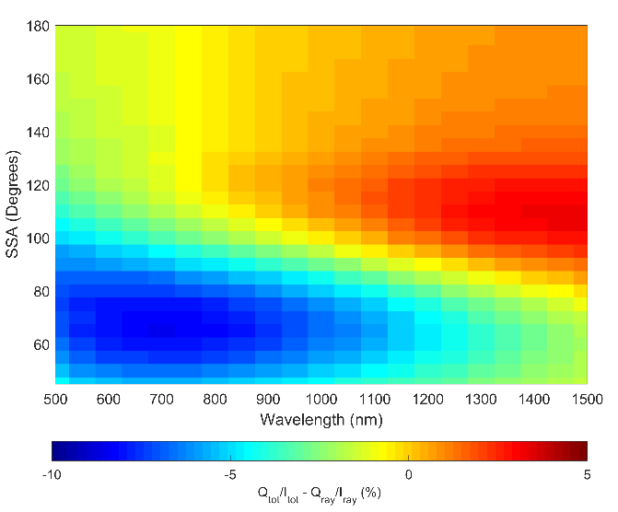

Figure 0: Absolute percent change in linear polarization between a sample atmosphere that contains aerosol and one that does not.

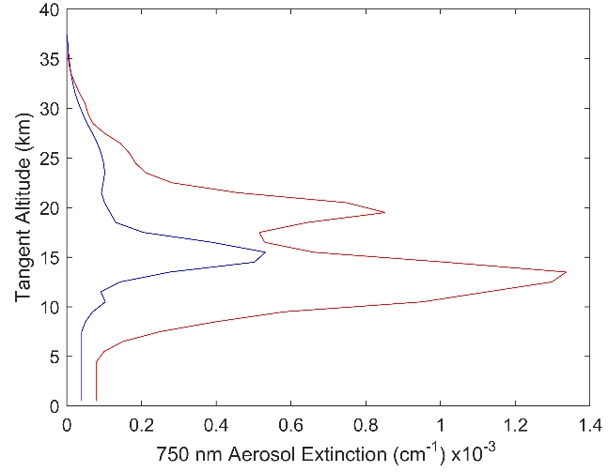

Figure 1: The two aerosol profiles used in this study. The blue is a background aerosol extinction levels, and the red curve is a representative aerosol profile after the Nabro eruption.

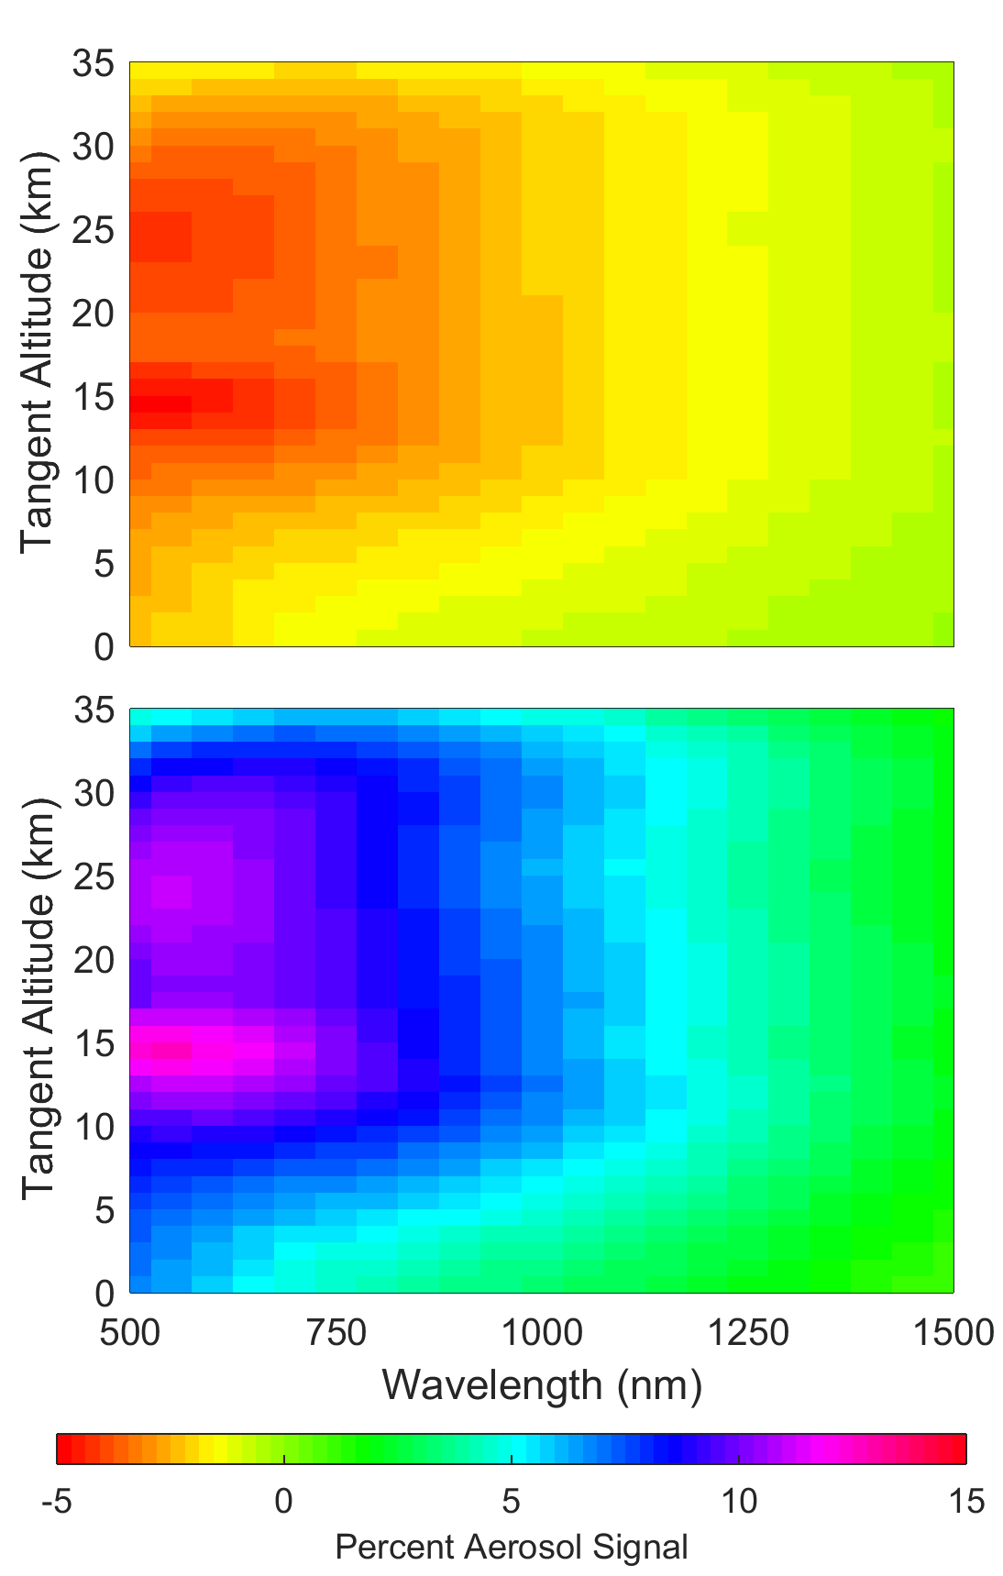

Figure 2: A computation of the percentage of aerosol signal change in the horizontal and vertical polarizations compared to the scalar. The top, and bottom figures are the horizontal, and vertical polarization respectively. The geometry for the simulation is set up with SZA of 45o and SSA of 60o with an Albedo of 0 and using the background aerosol profile.

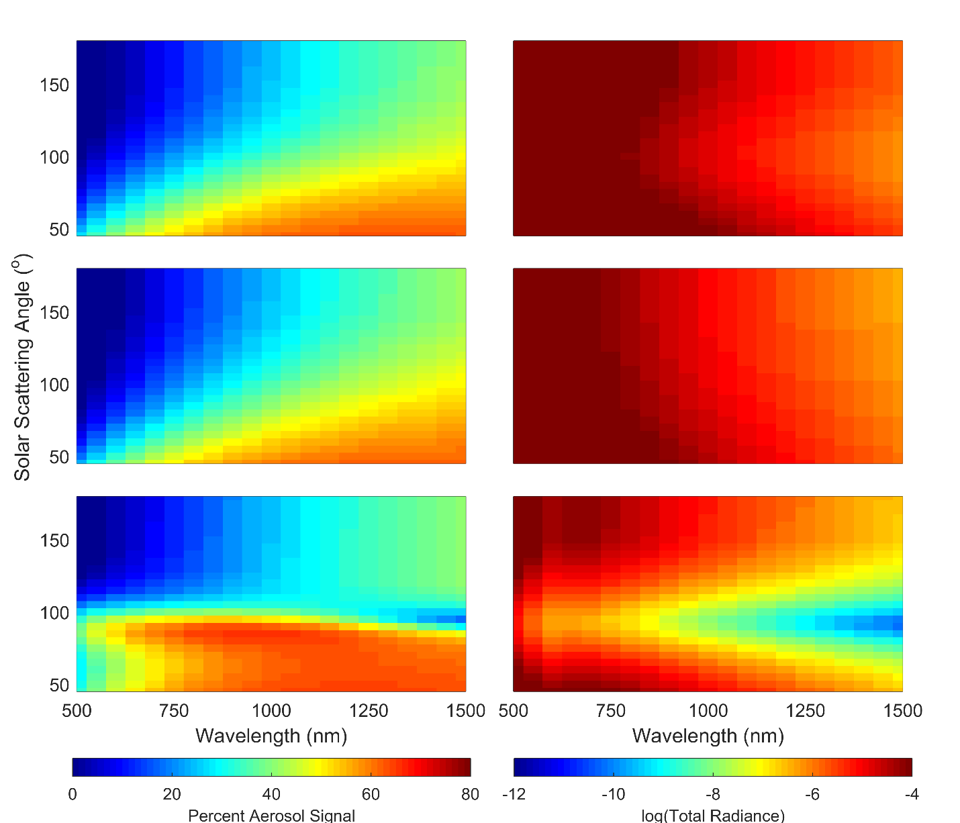

Figure 3: Left:A computation of the percentage of aerosol signal over the total radiance for a three polarizations. The top, middle, and bottom figures are the scalar, horizontal, and vertical polarization respectively. The geometry for the simulation is set up with SZA of 45o and at an altitude 15.5 km with an Albedo of 0 and using the background aerosol profile. Right: The same geometry as the left column except the log of the total radiance for each polarization is shown.

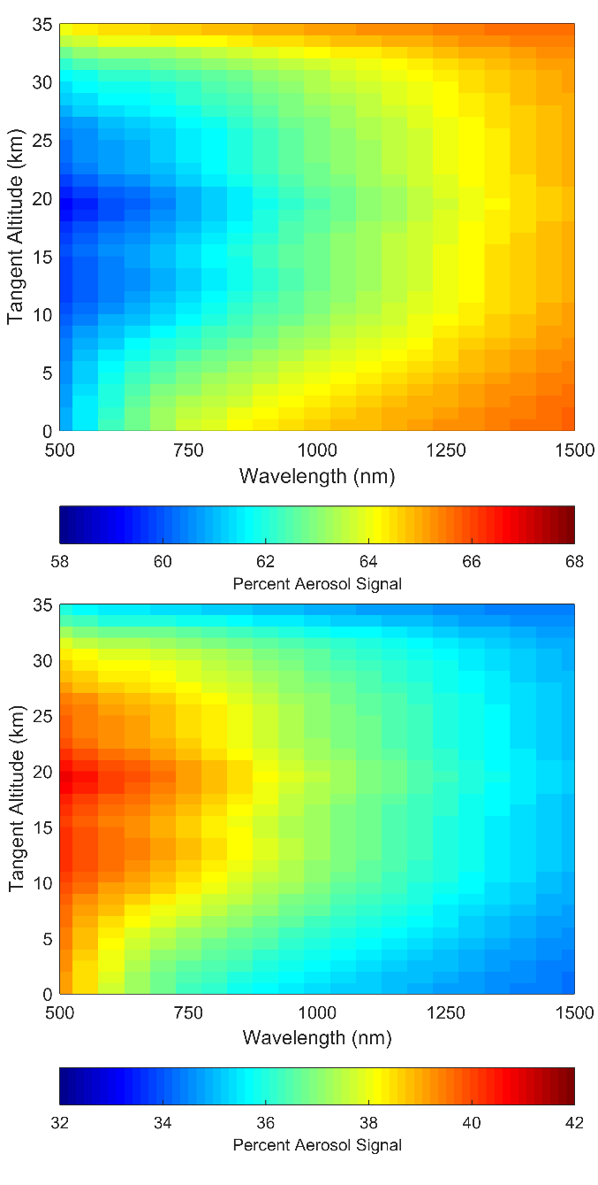

Figure 4: A percent of the linear polarized radiances over the scalar radiance, the top and bottom figures are the horizontal and vertical polarizations respectively. The radiances were calculated with a geometry of 45o SZA and 60o SSA with an albedo of 0 and using the background aerosol profile. Note that the scale for each plot are different.

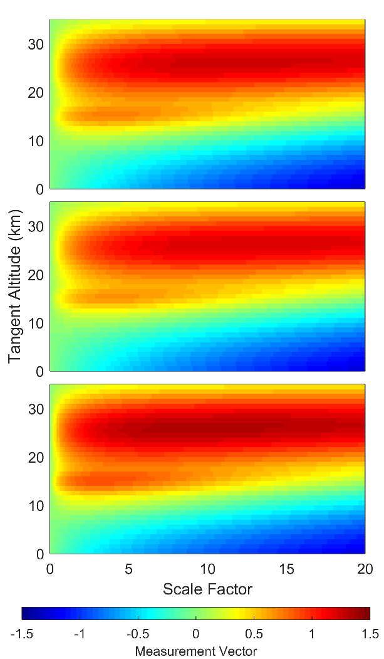

Figure 5: The background aerosol profile scaled by a factor used to calculate aerosol measurement vectors for 750 nm with a SZA of 60o and SSA of 45o with an albedo of 0. The three panels are the scalar, horizontal, and vertical polarizations from top to bottom.

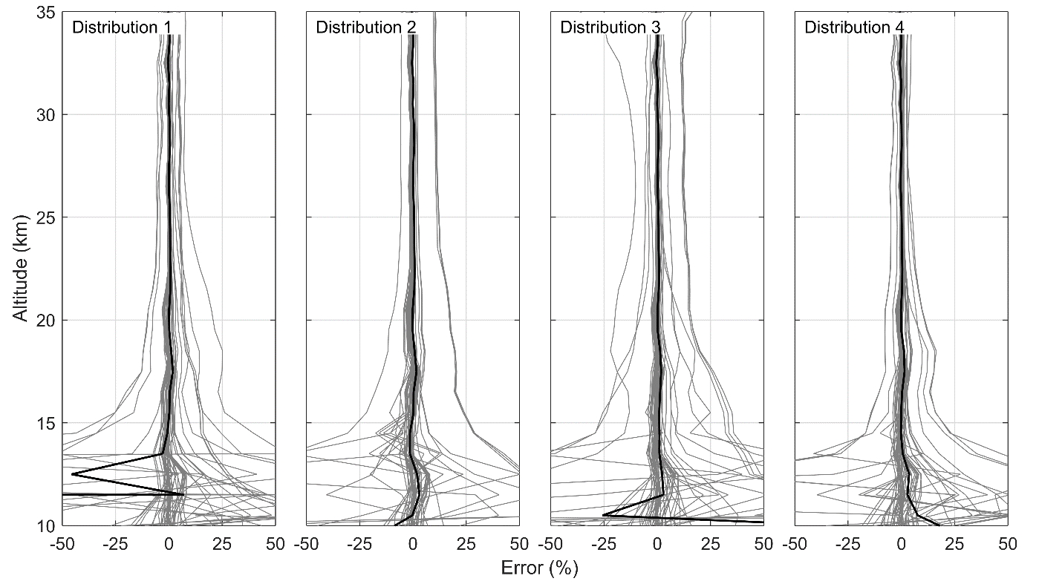

Figure 6: Percent differences of the retrieved aerosol profiles for the scalar retrieval versus the vector retrieval. Each column represents a different particle size distribution and the labels can be cross referenced in Table 1.

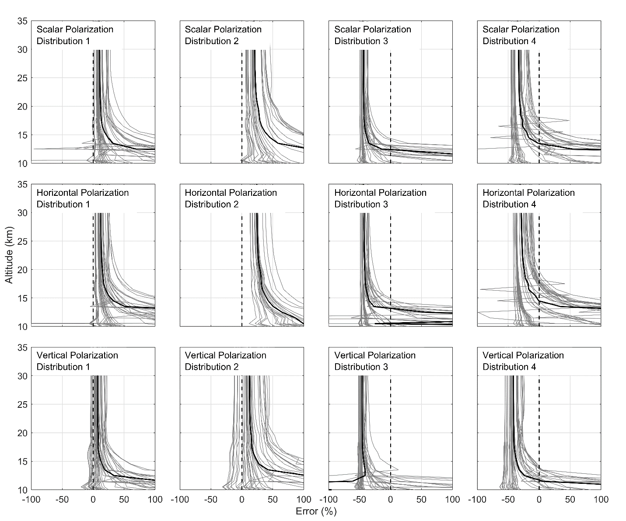

Figure 7: The retrieved aerosol profiles for each unique combination of geometry and aerosol profile are compared again the known original states. The plots are separated into 12 cases. The four columns represent the four particle size distributions used for the analysis as listed in Table 1. From the top to bottom row are the scalar, horizontal, and the vertical polarization.

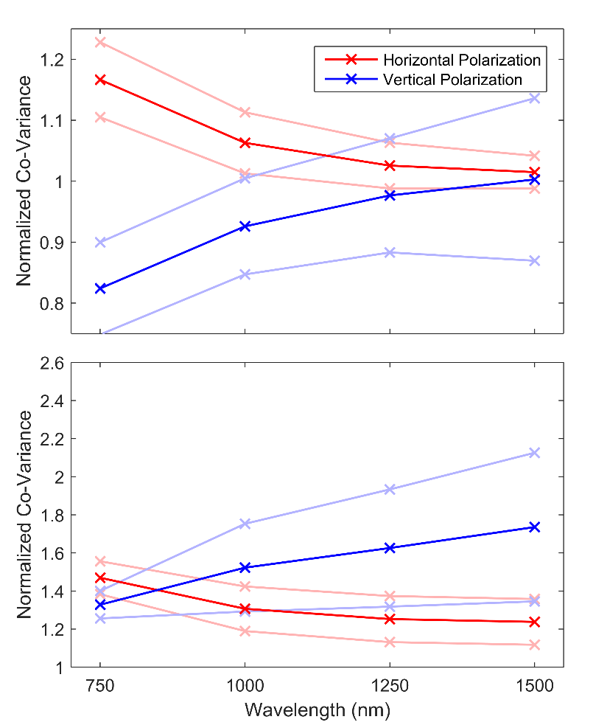

Figure 8: Average of the normalized co-variances for the horizontal and vertical polarization compared to the scalar case for the various selected wavelengths for the volcanic extinction profile. The faded line represent one standard deviation from the average. The top panel is for a compensated instrument and the bottom panel is an uncompensated one.